Computer Networks
2nd Year, 1st Semester
2022

Tutorial 2

- State the three types of addresses, operating layer and number of bits used to represent the address used in TCP/IP.\

Physical Address – MAC Address uses 48 bits
Logical Address - IPV4 Address – 32 bits / IPV6 – 128 bits
Port Address - Port Address – 16 bits

- What is the version of the current IP addressing scheme and the version of the next IP addressing scheme that will be using in the future?
  - Current – IPV4
  - Future – IPV6

- For IP addresses in each class show network bits and host bits by a diagram.
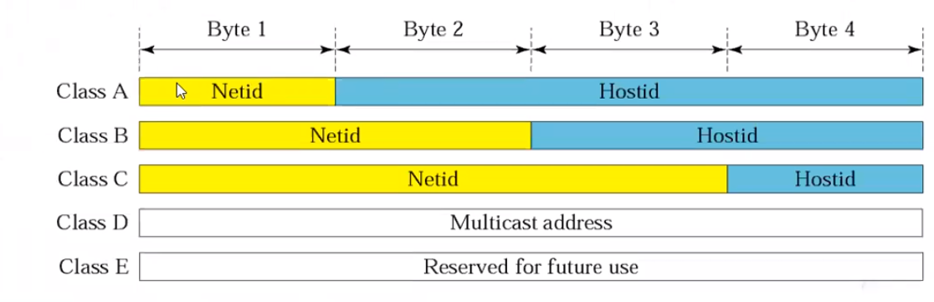

Class A – first octet – NetID last three octets – Host ID.
Class B – first two octets – NetID. Last two octets – Host ID
Class C – first three octets – NetID. Last octet – Host ID

- Write down the ranges of the IP address classes.
Address Class | Range of the first octet
Class A | 0 to 127
Class B | 128 – 191
Class C | 192 - 223
Class D | 224 - 254

- Write the class, net ID and the host ID of the following addresses.
Network Address | Class | Net ID | Host ID | Network address | Broadcast Address
101.2.3.4 | A | 101 | 2.3.4 | 101.0.0.0 | 101.255.255.255
200.20.10.5 | C | 200.20.10 | 5 | 200.20.10.0 | 200.20.10.255
192.168.16.100 | C | 192.168.16 | 100 | 192.168.16.0 | 192.168.16.255
25.10.100.200 | A | 25 | 10.100.200 | 25.0.0.0 | 25.255.255.255
180.2.150.2 | C | 180.2.150 | 2 | 180.2.150.0 | 180.2.150.255

- Find the network address and the subnet mask for the following IP addresses.
  - 172.19.67.3: Network Address – 172.19.0.0, Subnet Mask – 255.255.0.0
  - 205.90.46.234: Network Address – 205.90.46.0, Subnet Mask – 255.255.255.0
  - 123.65.89.0: Network Address – 123.0.0.0, Subnet Mask – 255.0.0.0

- State the type of the following IP addresses.
  - 172.16.25.9 – Class B address, Class B private address
  - 192.168.89.0 – Class C private range address
  - 127.0.0.90 – Loopback address
  - 255.255.255.0 – Class C subnet Mask
  - 255.255.255.255 – Limited broadcast Address
  - 0.0.26.8 – Specific host on this network

    - What are two main components of an IP address? Network ID, Host ID

    - Analyze the following IP addresses.

Find out which of the following addresses belong to the same network (no sub -netting / classful IP addressing). Explain why.
- 123.4.6.2 123.4.78.9 132.14.56.12 123.4.0.0
- 10.0.0.1 10.1.1.1 10.1.2.2 11.0.0.1
- 172.16.16.16 172.17.16.16 173.16.16.16 173.16.16.20

Answer is 3 because they’re all within the range of class B private network addresses.

    - You are given the network address 180.150.0.0; you are required to have 5 subnets. What is the minimum number of Host Bits can you take into the Network Bits for this purpose?
Write down the addresses of 5 subnets. (Write in binary where necessary). Write the subnet mask for the network.

This IP address comes under class C IP addresses which has 3 octets as networks bits
Minimum Number of hosts = (2^8) – 2 = 254

Subnet Mask – 255.255.255.0
    - A company is granted the network address 203.80.64.0 The company needs six subnets. Design the subnets and subnet mask. Also write the first 2 and last 2 IP addresses of the hosts in each of those subnets.

12. Show the 8 subnets obtained by subnetting the address 172.16.0.0/16 , the resulting subnet mask, the corresponding broadcast addresses, and the range of valid host addresses.

      - An organization is granted the block 211.17.180.0 in class C. The administrator wants to create 32 subnets.
- Find the subnet mask and the number of addresses in each subnet.
- Find the first and the last address in the first subnet.
- Find the first and the last address in the last subnet (subnet 31)

      - compute the sub-network address for the following IP addresses, given the subnet mask,
- 201.14.78.65 255.255.255.224
- 180.25.21.172 255.255.255.192
- 18.250.31.14 255.254.0.0
- 10.30.36.12 255.255.255.0
- 10.6.24.20 255.255.240.0

      - Compute the available number of sub networks and possible host addresses in each subnet.
  - The subnet mask for a class C network is 255.255.255.192
  - The subnet mask for a class B network is 255.255.224.0
  - The subnet mask for a class C network is 255.255.255.248
  - The subnet mask for a class A network is 255.255.248.0

- RH company has 9 branches in Colombo district. The company network has the network address of 152.16.0.0.
  - Write subnet addresses which can be given to the branches.
  - How many hosts can be existed in a branch?
  - Calculate the total number of available hosts in all the branches.
  - Write the 10th available IP address of the 5th branch.
  - Write the last 4 IP addresses of the 9th branch.

